Downloading and setting up the free software Audacity

This is a guide to how to download and setup Audacity (a piece of free, open source software for recording and editing sounds). Please note the following before downloading and installing Audacity onto your computer:
- It is assumed you have Windows XP, as this guide is based on the setup of a computer with Windows XP, (although it should work on other operating systems, there is no guarantee that this will be the case.)
- You should have a soundcard in your computer which enables you to record and play sounds.
- You have a pair of speakers/headphones and a microphone connected to the soundcard.
- You have the access rights on your computer to install the software.
- You have internet access to be able to download Audacity before installing it onto your computer.

Quick guide for downloading and installing audacity:
- Launch your web browser (e.g. Internet Explorer, Mozilla Firefox), and go to the web site http://audacity.sourceforge.net
- Click on ‘Download’ at the top of the page, shown below:
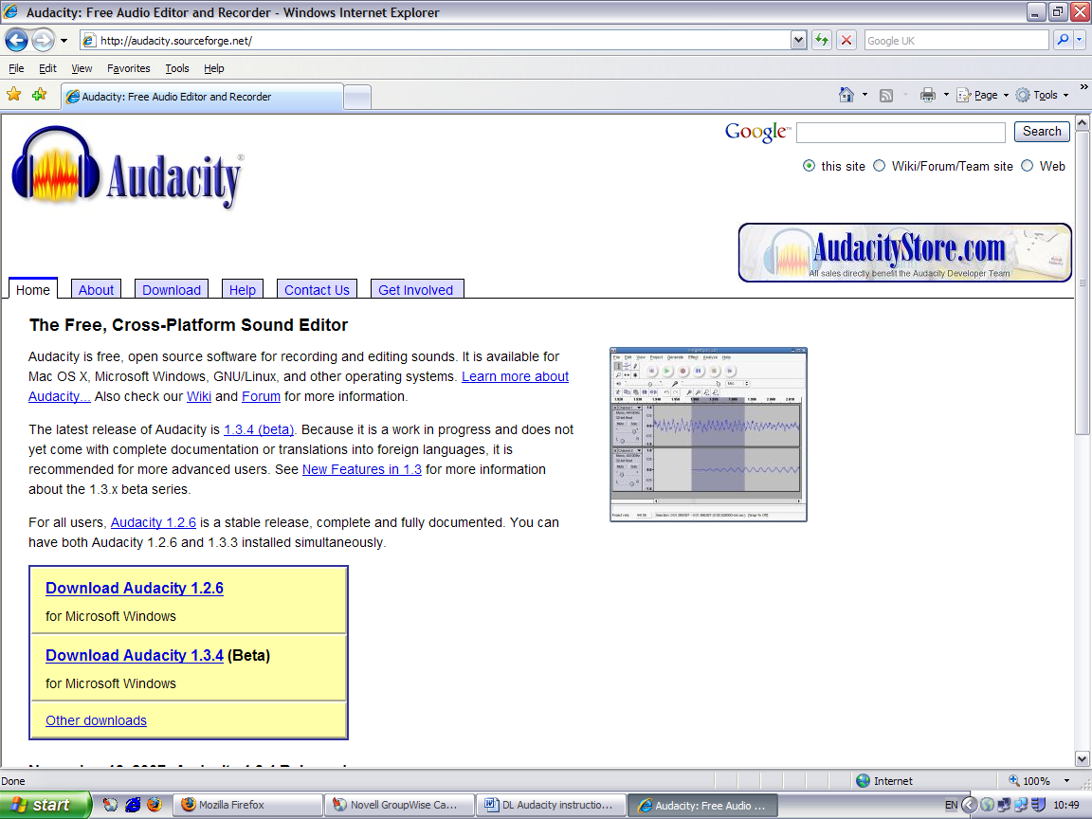
- This will take you to the page shown below which will enable you to download the Audacity installer for your operating system. Click on ‘Windows’.

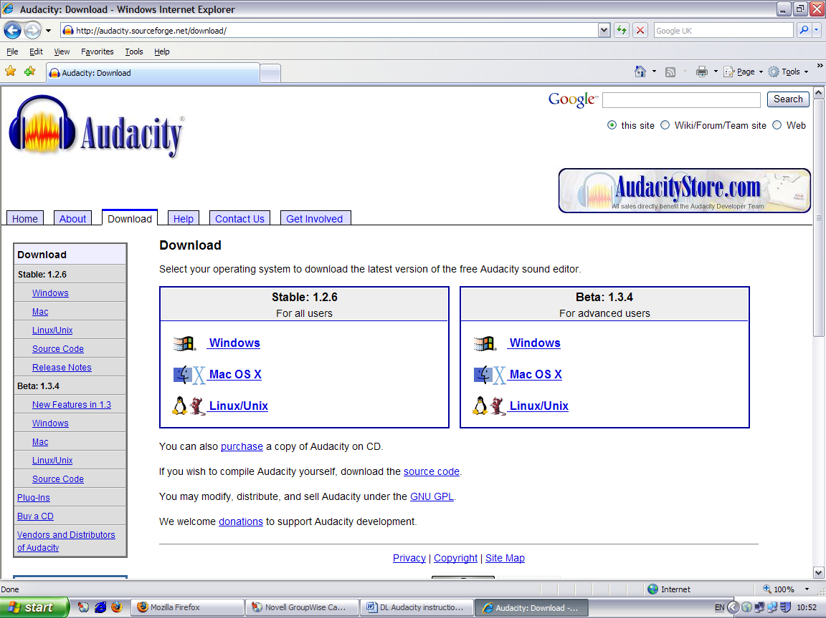
** It is recommended that you download the latest stable version at the time when you visit the website. If you run on other operating systems such as OS X or Linux/Unix, please follow the link to the relevant download pages.**
- You should now come to the page shown below, click on ‘Audacity 1.2.6 installer’.
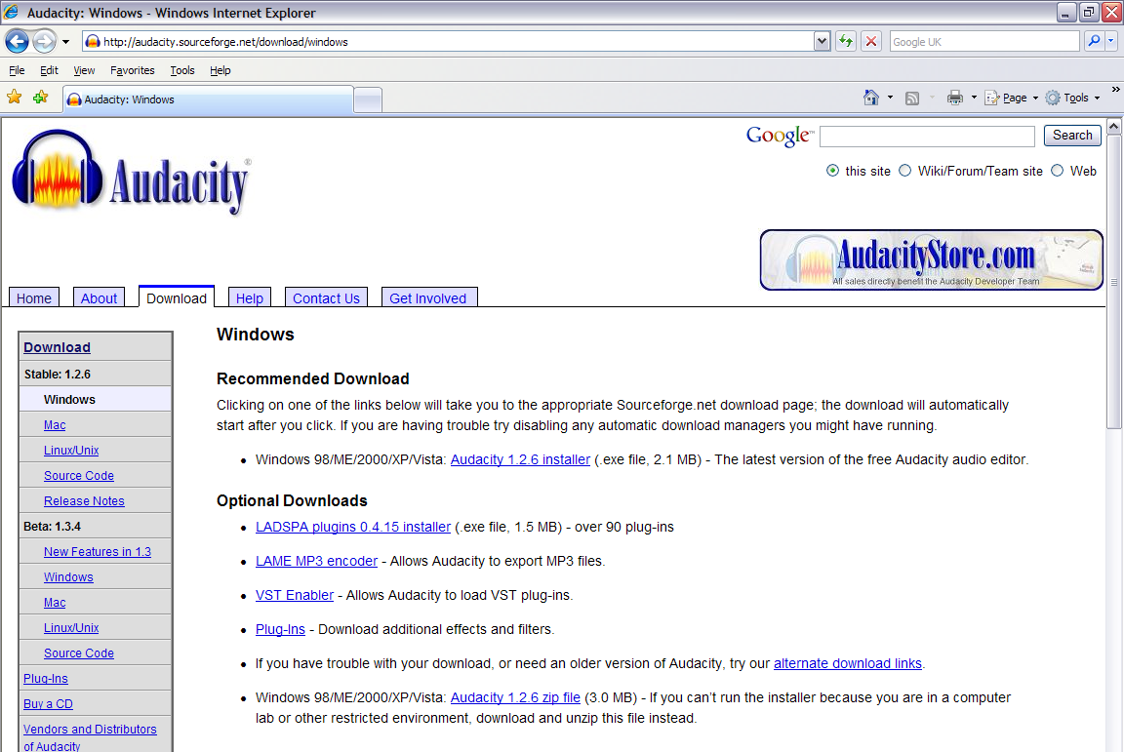

- You’ll then be brought to the sourceforge.net download page. You might be asked to enter your email, but you do not have to. Just click on ‘Close.’

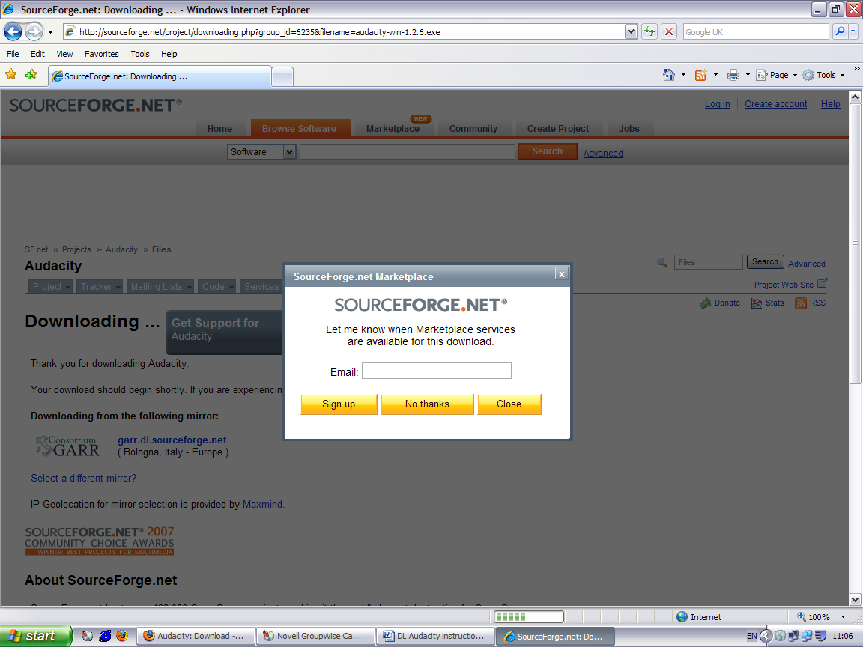

- If the download does not start immediately, right click on the ‘this direct link’ link and select ‘Save Target As…’ as shown below:
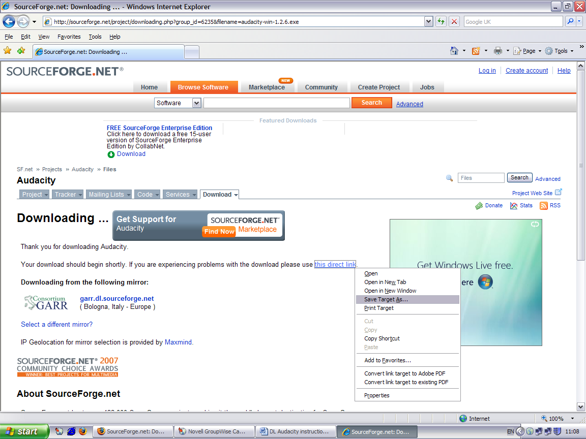

- A new download window should then pop up (shown below) and you will need to save the Audacity installer somewhere on your computer before installing. For ease, you could save it onto the desktop.

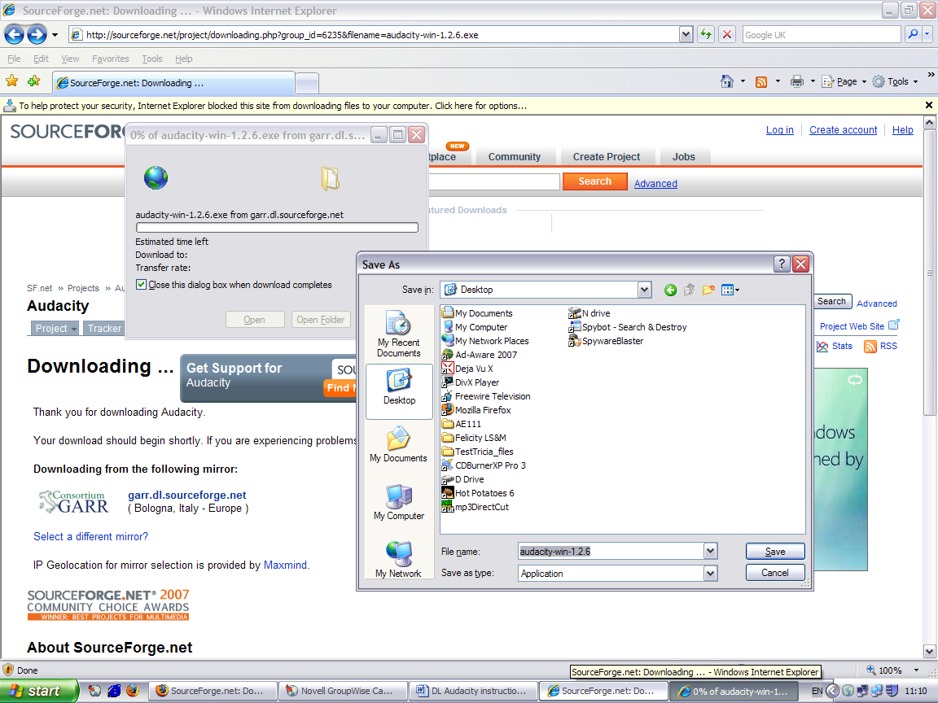

- Once the installer has been downloaded and saved on your desktop, please go to your desktop (or wherever you have saved the installer to), and run the installer by double-clicking on it, and you should be presented with this screen below:

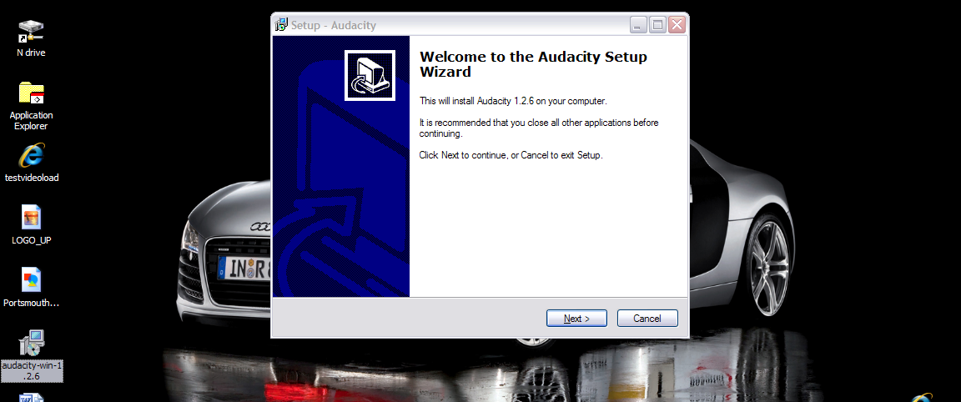

- Click on ‘Next >’ to continue to the next screen.
  - On the next screen, please select ‘I accept the agreement’ and click on the ‘Next >’ button.
  - Click on the ‘Next >’ button again to continue onto the next screen.
  - You should then be presented with the screen to ask you where you want to install the software to, if the C: drive is ok with you, just click ‘Next >’.
  - And then the ‘Next >’ button and the ‘Install’ button to install the software.
- Now Audacity should be installed.

Quick guide for downloading and installing the Lame mp3 encoder:
- The Lame mp3 encoder enables you to encode the audio clip that you record into mp3 format (which is a lot smaller than raw audio files, i.e. it will be quicker to upload and download mp3 formatted files than raw audio files). You will need to install this encoder in order to export mp3 files in Audacity.

- To download the Lame mp3 encoder for Audacity, launch your web browser and go to the website http://lame.buanzo.com.ar (you will also be able to find the reference to this website from the Audacity download pages, http://audacity.sourceforge.net/help/faq?s=install&item=lame-mp3, where you will find a simple instruction also on how to install the encoder).

- Once you have downloaded and saved the encoder ‘zip’ file, you will need to extract the zip file and copy the lame_enc.dll file from the zip file to somewhere so that Audacity can find it and use it when you want to export to mp3 files. To extract the zip file, you right click on it and choose ‘sent to’ or ‘extract all’ and then follow the instructions.

- For ease, let’s put this lame_enc.dll into the directory where Audacity is installed. By default, Audacity has been installed to the C:\Program Files\Audacity, so if you go to your desktop, double click on ‘My computer’, then into the ‘C: drive’, then ‘Program files’, then ‘Audacity’. You will then need to copy the lame_enc.dll file from the extracted zip file folder into here.

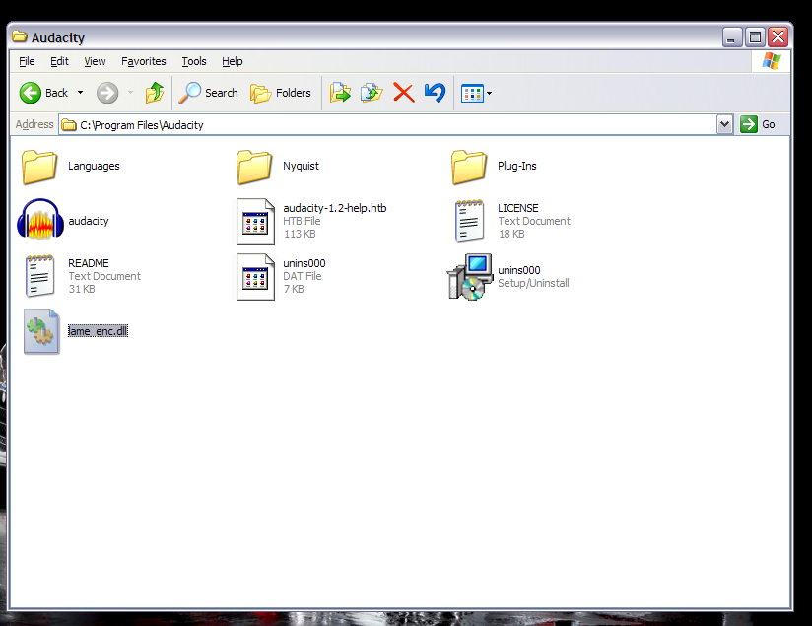

Quick start guide in Audacity:
- To can start Audacity by either double clicking on the desktop icon or clicking on the ‘Start’ button, then ‘Programs’ and then ‘Audacity’. The first time you start it up, it will ask you for the language you want to use Audacity in, please select ‘English’. This is what it will look like when you have launched Audacity:
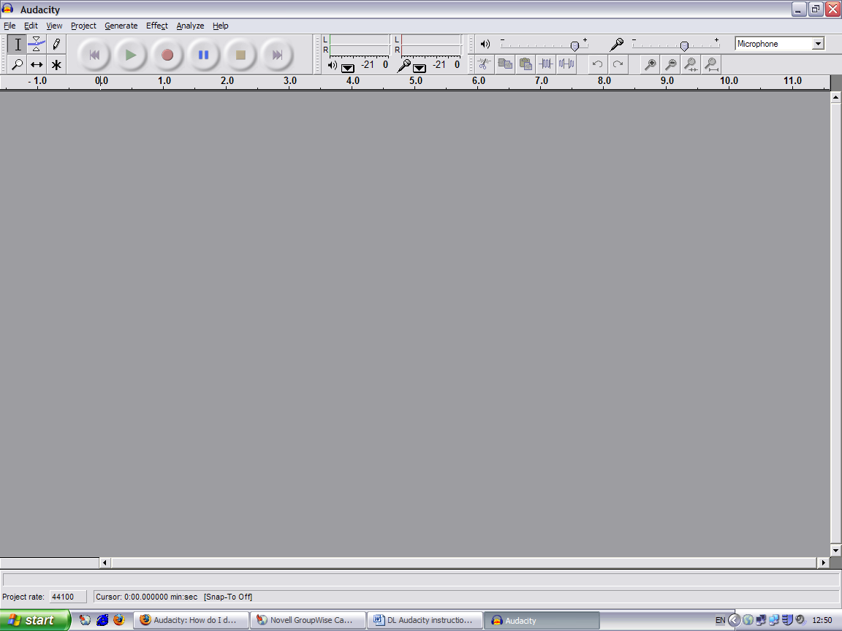

- To record sound, you simply press the round red button at the top and speak into the microphone. Do a test recording first as you might need to adjust the volume or the microphone and the settings, if you find the recording to be a bit ‘quiet’. To do this, double click on the speaker icon on the right of your bottom task bar (next to the clock as shown in picture below), and you might need to click on ‘Options’ at the ‘Volume Control’ to show the microphone volume if it is not showing already. You might also want to try to enable the ‘Advanced Controls’ under the ‘Options’ menu and enable the ‘Boost’ option in the Advanced Microphone settings.
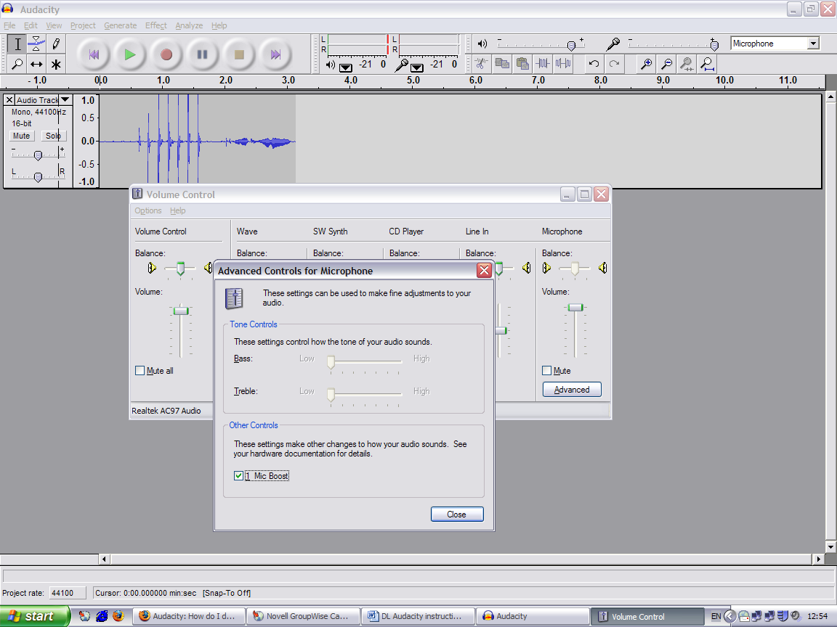

- To play what you have recorded, press the green ‘arrow’ button at the top.

